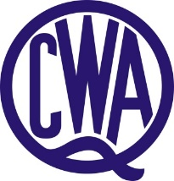
Q.C.W.A. BILLIE MAYKIN BURSARY

Billie Maykin Memorial Bursaries (each $500 per annum) are offered annually to secondary/tertiary students who are academically able but because of financial circumstances, would not otherwise complete secondary/tertiary level course.

Bursary to be administered by the QCWA State Executive Board.

Applicants to submit:

- Written proof of achievement
- Demonstrate the need for financial support
- Three written, current character references
- Details of or proposed/continuing
- Short (500 word) resume of applicant's achievements and future aspirations

Bursary available for duration of course provided that recipient:

- Maintains a satisfactory academic achievement
- Reapplies for annual review for possible continuation.

As part of this bursary recipients may be asked during the year to make their time and skills available on a voluntary basis to assist the Association with projects and events.

QCWA will arrange a presentation function for this bursary and recipients will be asked to attend. Family and friends will also be welcome at this event.

Application forms can be found on the QCWA website or through QCWA State Office on (07) 3236 6419.

Applications close 31 January.

Applications to be submitted to:
The State Secretary
QCWA
11 Cleveland Street
STONES CORNER Q 4120

Or via email to: secretary@qcwa.org.au

