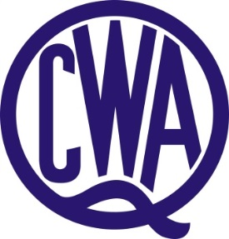

QCWA BORDER DIVISION BURSARY –
Area covered by Border Division

QCWA Border Division is offering one bursary annually of $1,000 to a mature age student from the age of 21 who is a Queensland resident. Preference may be given to a resident of Border Division. Applications are invited from mature age students from the age of 21 who are furthering their education and who are experiencing financial difficulties.

The bursary is to be administered by the State QCWA State Executive Board. Both male and female students are welcome to apply.

Applicants to submit:

- Written proof of achievement.
- Demonstrate the need for financial support.
- Three written, current character references.
- Details of course.
- Short (500 words) resume of applicant’s achievements and future aspirations.

The QCWA however reserves the right to limit the period over which a bursary is granted to any one student.

Applications forms are available online – www.qcwa.org.au or please contact QCWA State Office on (07) 3236 6419.

Applications close 31st January.

Applications to be submitted to:

The State Secretary
QCWA
11 Cleveland Street,
STONES CORNER QLD 4120

or Email: secretary@qcwa.org.au

