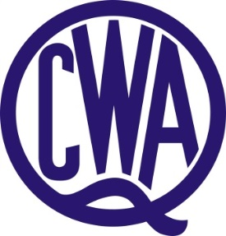

DARLING DOWNS DIVISION DANCE BURSARY

QCWA Darling Downs Division is offering one bursary annually of $1,000 to a public student. Applications are invited from public students enrolled as a dance student at tertiary level and whose home address is from Regional and Rural Queensland. Both male and female students are welcome to apply.

Applicants to submit:

- Written proof of achievement.
- Demonstrate the need for financial support.
- Three written, current character references.
- Details of course being undertaken.
- Short (500 words) resume of applicant’s achievements and future aspirations.

The QCWA however reserves the right to limit the period over which a bursary is granted to any one student. Application forms are available online at www.qcwa.org.au or via State Office on (07) 3236 6419.

Applications close 31 January.

Applications to be submitted to:
State Secretary
QCWA
11 Cleveland Street
STONES CORNER QLD 4120

Or via email: secretary@qcwa.org.au

