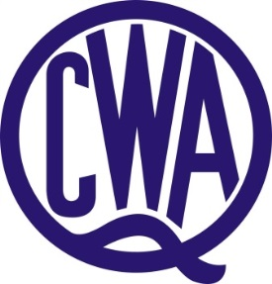

RUTH FAIRFAX MEMORIAL BURSARY

Two QCWA Ruth Fairfax Memorial Bursaries of $2,500.00 each is offered annually to students under the age of 25 years and whose permanent home address is the State of Queensland who has received an offer to enter a Tertiary Institution and intends to pursue a course with major rural content.

The Bursaries are to be administered by the QCWA State Executive Board. Applicants may be interviewed. Both male and female students are welcome to apply.

Applicants to submit:

- Written proof of achievement
- Demonstrate the need for financial support
- Three written, current character references
- Details of proposed course
- Short (500 word) resume of applicant's achievements and future aspirations

50% of Bursary to be awarded immediately with balance to be paid on receipt of a favourable 6 month report. The awardee is requested to submit a 12 monthly report on their progress and use of the funds awarded. The QCWA however reserves the right to limit the period over which a bursary is granted to any one student.

As part of this bursary recipients may be asked during the year to make their time and skills available on a voluntary basis to assist the Association with projects and events.

The QCWA will arrange a presentation function for this bursary and recipients will be asked to attend. Family and friends will also be welcome at this event.

Applications forms are available online – www.qcwa.org.au or through QCWA State Office on (07) 3236 6419.

Applications close 31 January.

Applications to be submitted to:

The State Secretary
QCWA
11 Cleveland Street
STONES CORNER Qld 4120

Or email to: secretary@qcwa.org.au

